- [[QuestionCode : 10221ثصa5]]
[[Question:
What is the name of this element?
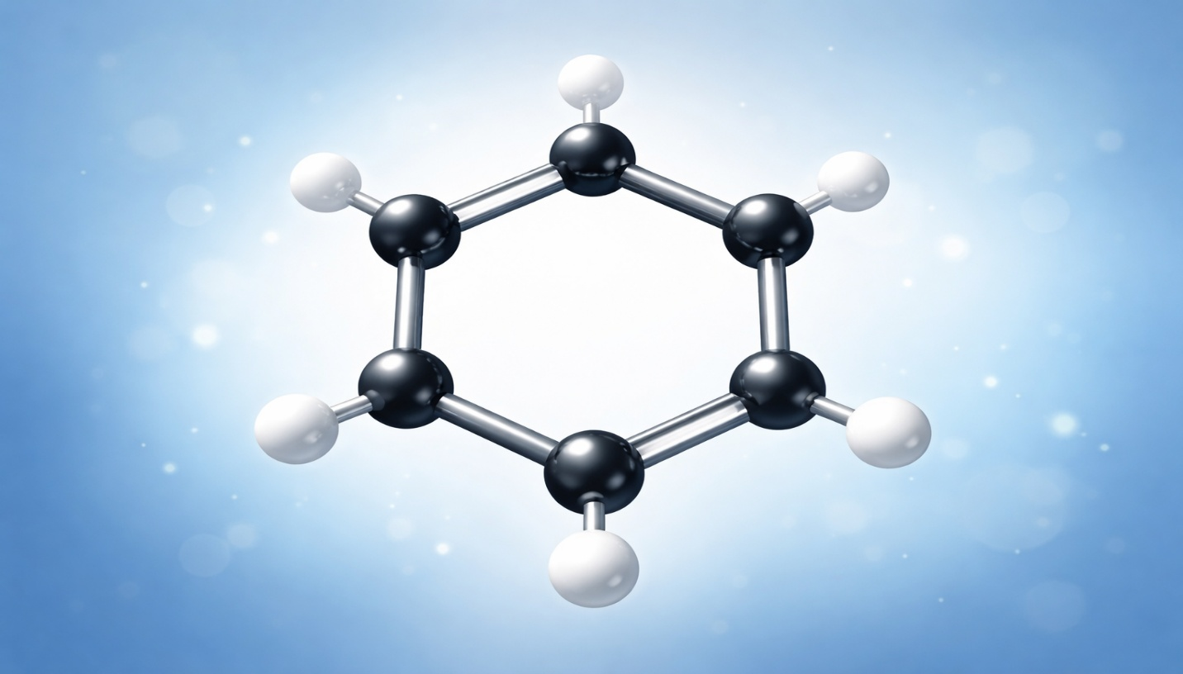
What is the name of this element?
]]

[[ModelAnswer : Benzene]]

