- [[QuestionCode : 1025]]
[[Question:
What is the name of this element?
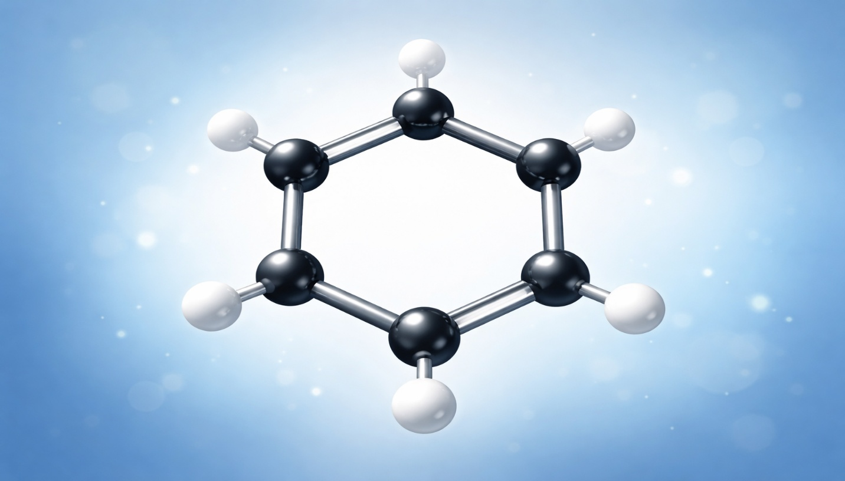
]]

[[ModelAnswer : Benzene]]
2. [[QuestionCode : 1125]]
[[Question:
Which gas is most abundant in the Earth's atmosphere?
]]
[[Choices:
  - Oxygen *
  - Nitrogen
  - Carbon dioxide
]]

3.[[QuestionCode :287558]]
[[Question: Water (H₂O) is a compound made of hydrogen and oxygen ?
]]
[[Choices:
- b) True *
- c) False
]]
- [[QuestionCode :Q1-1234]] [[Question:
Where is gold and oxygen?
]]
[[Choices :

-  



